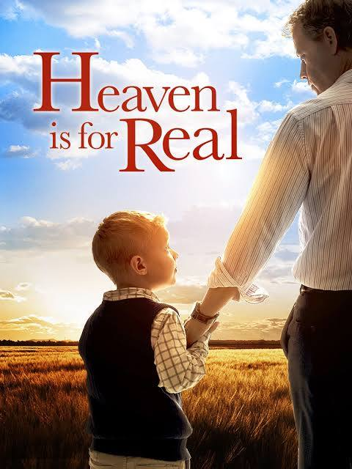

Friday night at the Movies. October 24th at 7:00 P.M.

St. John the Baptist Parish Hall, Wareham

Sponsored by the Anglican Foundation of Canada

And The Parish of Indian Bay

Refreshments provided, popcorn and drinks, during the intermission.

ALL ARE WELCOME TO SHARE IN AN EVENT OF FELLOWSHIP WITH OUR EXTENDED CONGREGATION