The Diocese of Central Newfoundland

**Parish Profile**

The Parish of Indian Bay

**Parish Mission Statement**  
**We are called to be a part of the Body of Christ. Our goal is to know and love Jesus and make Jesus known by all we meet. To be a Parish that lives by Faith, is known by Love and is a Voice of Hope in the communities it serves. We Welcome all that enter our doors with open arms.**

**The Holy Trinity**

**The idea that God is three in one is confusing to many people. God exists as three persons, yet he is one being. Each person of the Trinity—the Father, Son, and Holy Spirit—has a separate identity while yet possessing the full nature of God.**

**Jesus is the divine Son of God. This does not mean that Jesus was created by God. We know this because Scripture states that Jesus has always co-existed with God (John 1:1-3). And while on earth, Jesus himself declared the same. Colossians 1:15-17 says, “Christ is the visible image of the invisible God. He existed before God made anything at all and is supreme over all creation. Christ is the one through whom God created everything in heaven and earth…He existed before everything else began, and he holds all creation together.”**

**God the Holy Spirit is also deity. The Spirit has eternally co-existed with the Father and the Son and was present at creation (see Genesis 1:2). Jesus said of him, “I will ask the Father, and he will give you another Advocate…He is the Holy Spirit, who leads into all truth…When the Father sends the Advocate as my representative—that is, the Holy Spirit—he will teach you everything I have told you” (John 14: 16, 26).**

**Jesus called the co-existing Spirit holy because he is the Spirit of the Holy God, the third person of the triune Godhead. Rest assured that as you seek to know God, you will feel the presence and promptings of the Holy Spirit.**

This photo represents who we are and who we want to be, our focus is on the youth and our future.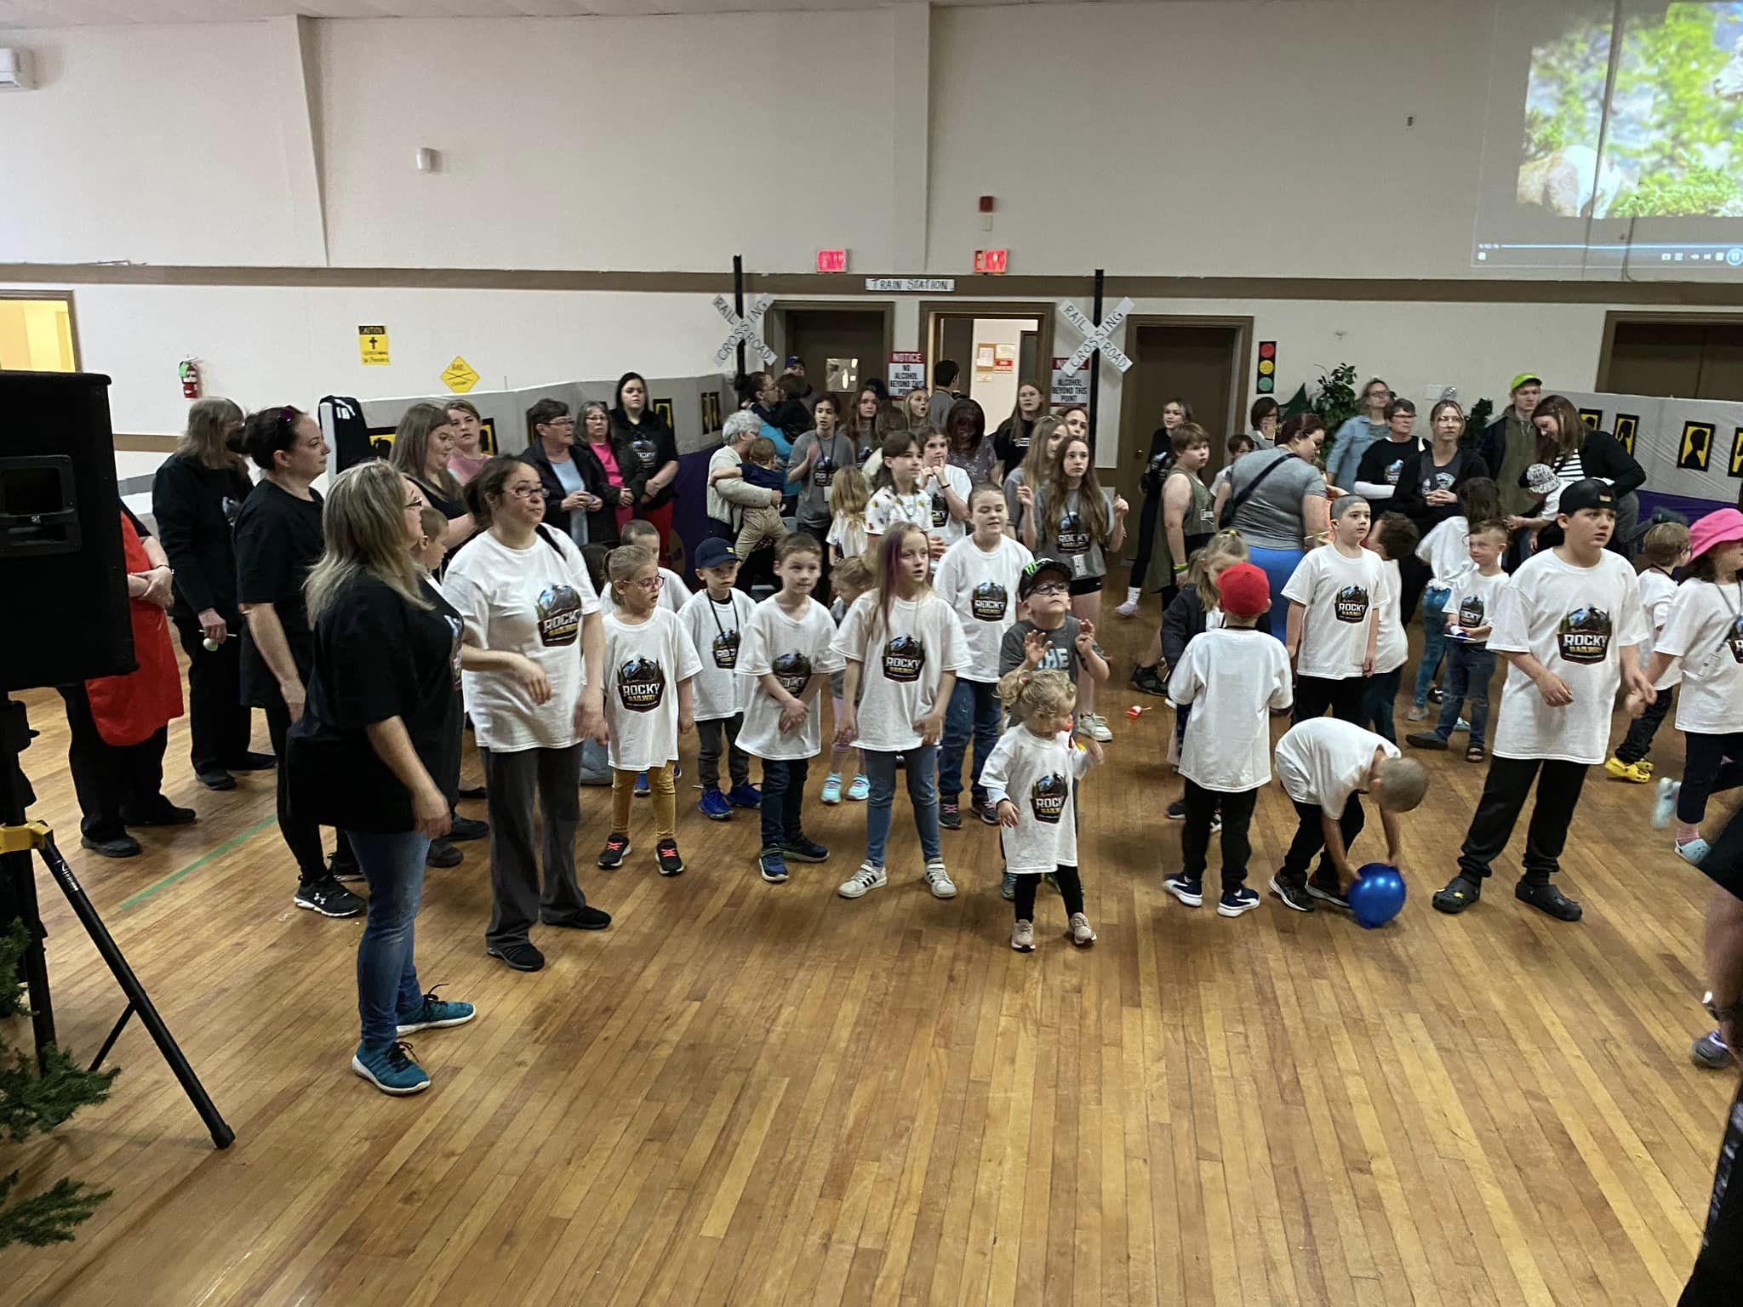

Communication  
**Ways to access our information or communicate with us**

**Mailing Address: The Anglican Parish of Indian Bay**

**P.O. Box 30, Trinity, NL., A0G 4L0**

holytringf@nf.sympatico.ca

**Telephone:**

- Office - Fax

- Parish Rectory 709-678-2507

**Email Address** parishofindianbay@gmail.com  
**Website:** www.indianbayparish.com

**Facebook** Yes _X__ No______

**Twitter** Yes_______ N0___X____

**Location and Geography**

**Control and left click to follow links**

Map on Website <https://goo.gl/maps/ajfh8XEjDKynufu47>

**Website information of Our town or Region**

[Home | Centreville-Wareham-Trinity (townofcwt.com)](https://townofcwt.com/)

**Face book page: The Anglican Parish of Indian Bay**

[(2) The Anglican Parish of Indian Bay | Facebook](https://www.facebook.com/groups/337466983549665)

**Other VBS**

[(2) VBS Parish of Indian Bay | Facebook](https://www.facebook.com/groups/369123040260478)

**A Brief Description of our Location and Geography of the Parish**

**Control and left click to follow links**

[How To Get Here | Centreville-Wareham-Trinity (townofcwt.com)](https://townofcwt.com/tourism/how-to-get-here/)

[Churches | Centreville-Wareham-Trinity (townofcwt.com)](https://townofcwt.com/community/churches/)

[Town News | Centreville-Wareham-Trinity (townofcwt.com)](https://townofcwt.com/town-news/)

**A Brief Description of our Local Economy, Health Care and Schools**

**Economy:** [Business Directory | Centreville-Wareham-Trinity (townofcwt.com)](https://townofcwt.com/business/business-directory/)

Aunt Hannah’s Café & Gallery

Beauty & the Barber

Best view Homes

C.H. Parsons Ltd.

Chris’s Gas Bar

Cran-Pac Foods Ltd.

Custom Crafted Creations Ltd.

CWT Tax Services.

Everyday Electrical Inc.

Business Directory Cont’

Fair Island Creations

Fiberglass works Ltd. / Seabreeze Boats

Silver Fox Lounge

Green Haven Gardens

JOB Contracting Ltd.

Kittiwake Kuts

Land & Sea Pet Treats

Midway Convenience

Mr. Odd Jobs Inc.

Nick’s Home Construction

New-wood Manufactures

Ocean Wave Cottages

Quilting by the Shore

Roadside Grocery & Hardware

Snaps & Sweets

Sunset Grill & Motel

Tickled Pink

TMT Construction

The Hub Lounge

Universal Stone Works

Washed Ashore Antiques & Coffee Bar

Wood-Pick Enterprises Ltd.

**Health Care:** Centreville Clinic; Public Health Nurse

**Education: Centreville Academy**

**Private Colleges** nil

**Our People**

**Previous Clergy**

|  |  |  |  |
| --- | --- | --- | --- |
|  | Name | Term | Years From - To |
| Most Recent | Rev Daphne Parsons | 6 Years | 2017-2023 |
| 2nd. Previous | Rev David Coffin | 8 Years | 2009-2017 |
| 3rd. Previous | Rev Wayne Short | 3 Years | 2005-2008 |

**Number of Retired/Honorary Clergy ___1_**

**Number of Licensed Lay Ministers ___6__**

**Number of Sunday Schools ___0__**

**Number of Servers ___0_**

**Number of Eucharistic Ministers ___8__**

**Number of Trained Lay Visitors ___0__**

**Number of Choirs ___5__**

**Number of Men’s Groups ___0_**

**Number of Women’s Groups ___4_**

**Number of Bible Studies ___1__**

**Number of Youth Groups ___0__**

**Number of Organists __4___   
Number of other musicians __6___  
Does the Parish have a deacon? __No___**

**Other Points of Interest Concerning Our Lay Ministries or other Groups in our Parish**Lay Ministers and Minister meet every 2 months to do church schedules.

Involved in funerals, Cross Bearer and one on duty.

Men’s Choir, Joint Choir, Women’s Institute, Indian Bay Memorial University Community Hub,

Tops, Air Cadets, CWT Recreation, IBEC Ecosystem, 50 plus club, Tucamore Group, Youth Committee, Vacation Bible School VBS, Lions Club, Fire Department, and Firettes Women supporting the fire department.

At A Glance Information

**Parish Overview**

**Buildings   
Location of the Rectory:**

|  |  |  |  |
| --- | --- | --- | --- |
| **Our Churches** | **Location** | **Distance From Rectory** | **Church Hall  Yes/No**  **Basement/Attached Etc.…** |
| **St Albans** | **Trinity** | **.1 k** | **no** |
| **St Barnabas** | **Centerville** | **3.0 k** | **Yes** |
| **St John the Baptist** | **Wareham** | **6.5 k** | **Yes, not attached** |
| **St Mary the Virgin** | **Indian Bay** | **8.0 k** | **No** |
|  |  |  |  |
|  |  |  |  |
|  |  |  |  |

**Average Monthly Schedule see page 8**

We have regular meetings with individual churches for:

Vestry

Parish Council

ACW meetings

VBS involvement

Church Councils

Parish Warden Meetings

Graduation Function

Joint Special Sunday Praise and Worship Services on the 5th Sunday of all months with 5 Sundays, on a Church rotational basis.

Special Lenten Services

Special Easter Sunday Services

Special Christmas Services

World Day of Prayer Services

4 ACW Worship Services

Flower Services for all four Churches

Memorial Day Services

July 1st Services

Winter Carnival Service

Remembrance Day Services

Ministerial Services for The Indian Bay Parish

VBS for children ending with a special VBS Service

Contacts with shut ins, home visits as necessary

Visits to senior homes

Visits to Hospitals to visit those who are sick when possible.

Each month with 5 Sundays, we have a special joint service.

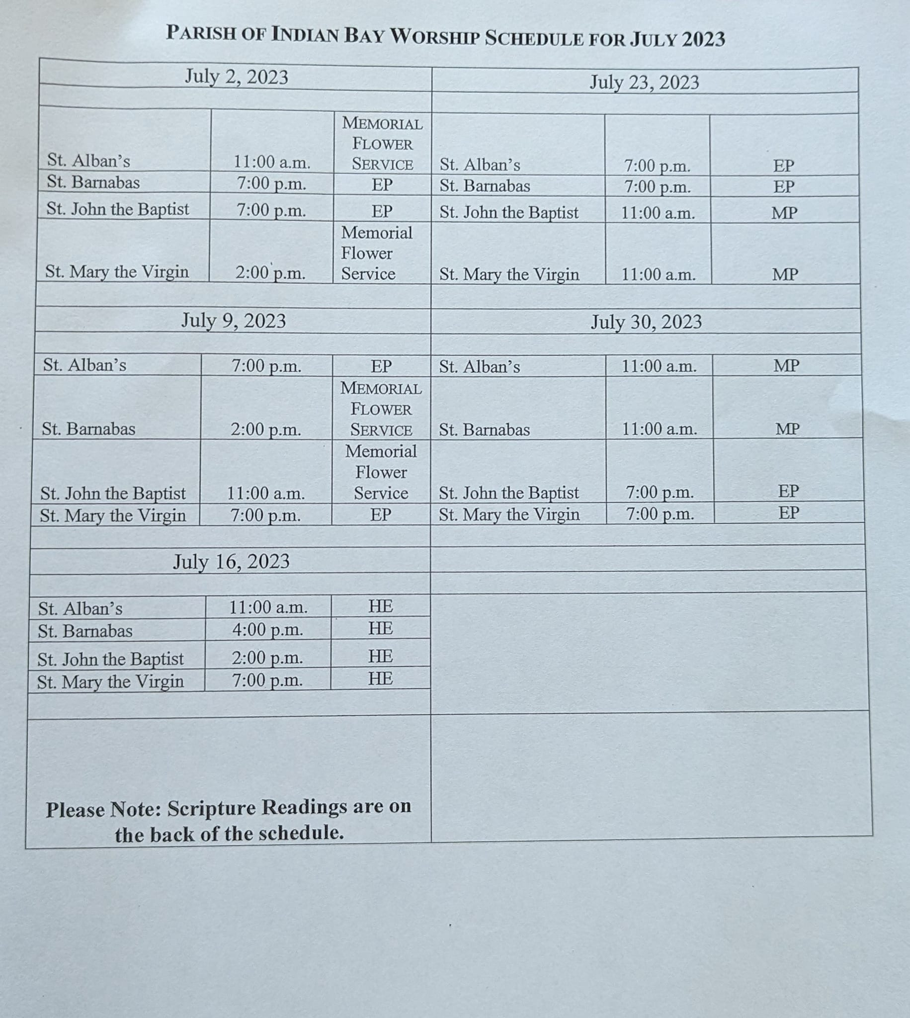

Above is a typical service schedule on a regular monthly basis.

**“Homework we have done, or have left to do” (yes no…etc.)**

* Does the parish have up to date family census information? _Yes_______
* In what year was the family census last updated? 2023________
* Does the Parish have an up-to-date Mailing List? No_________
* In what year was it updated? Nil_________
* Does the Parish have a regular up to date e-mailing List? No _________
* Our Cemeteries are well taken care of Yes_________
* Does the parish have a list of persons with special needs i.e. Home communicants, sick & shut in etc.? Yes________
* Has the parish begun a process of looking at the Bishop’s initial Charge and engaging the *Policy on Sustainable & Strategically Missional Ministry? _Yes_________________*

**What other items may need to be placed on this list?**

Oram’s Senior Home visits in Gambo, Bonnews Nursing Home visits in New-Wes-Valley,

Otterbury Manor Senior’s Home visits New-Wes-Valley.

|  |  |  |
| --- | --- | --- |
| **Item** | **Year: 2021** | **Year: 2022** |
| Number of Families on Parish List | 430 | 410 |
| Average Weekly Attendance | # affected by Covid | 100 |
| Number of Easter Communicants | # affected by Covid | 125 |
| Number of Baptisms | 5 | 4 |
| Number of Confirmations | 11 | 0 |
| Number of Marriages | 4 | 1 |
| Number of Burials | 24 | 39 |
| Number of Sunday School  List number registered, and estimate those who actually attend | 0  0 | 0  0 |
| Number of Choirs | 0 | 3 |
| Number of Altar Guilds | 4 | 4 |
| Number of Women’s Groups | 4 | 4 |
| Number of Men’s Groups | 0 | 0 |
| Number of Youth Groups | 0 | 0 |
| Greeters/Sides persons | 6 | 10 |
| Readers/lectors |  |  |
| Number of Bible Study Groups |  | 1 |

**Summary Parish Statistics for the past two years**

**Summary Parish Financial Statistics for the past two years**

parish.

|  |  |  |
| --- | --- | --- |
| **Item** | **Year: 2021** | **Year: 2022** |
| Number of Identifiable givers | 430 | 410 |
| Total Annual Envelope Offering (excluding cemetery & special collections) | $124,195.00 | $113,165.00 |
| Investment income (not cemetery) | $0.00 | $12,623.21 |
| Fund Raising income | $5,926.16 | $7,626.85 |
| Total Parish income (excluding cemetery & special collections) | $127,023.90 | $114,956.90 |
| Diocesan Assessment Due | $0.00 | $0.00 |
| Diocesan Assessment paid | $25,900.00 | $25,000.00 |
| Diocesan Arrears | $0.00 | $0.00 |
| Clergy Benefits Due | $0.00 | $0.00 |
| Clergy Benefits Paid | $53,766.24 | $56,132.96 |
|  | 2021 | 2022 |
| Clergy Benefits in Arrears | $0.00 | $0.00 |
| Number of Loans & Total Amount owing | $0.00 | $0.00 |
|  |  |  |
|  | **Year 2021** | **Year 2022** |
| Total Year End Balances in Congregations | $124,449.62 | $99,081.89 |
| Total Year End Balance in Parish Council Accounts | $118,055.23 | $127,818.53 |
| PWRDF Total Offerings | $3082.00 | $2951.50 |

**Parish Property**

**Annual Expenditures & Project Summary for last two years** *If there are more than five churches in the Parish, please use the next table as well*

|  |  |  |
| --- | --- | --- |
| **Type of Building** | Year **2021** | Year **2022** |
| Rectory |  |  |
| Church:  Location |  |  |
| Church:  St. Barnabas  Location Centreville | $ 46,252.72 | $ 49,698.18 |
| Church: St. John the Baptist  Location Wareham | $ 32,888.27 | $ 32,654.96 |
| Church: St. Albans  Location Trinity | $ 42,175.67 | $ 51,083.72 |
| Church: St. Mary the Virgin  Location Indian Bay | $ not available | $ 27,562.54 |
| Church Hall:  Location: | $ | $ |
| Church Hall:  Location: | $ | $ |
| Church Hall: ________________  Location ____________________ | $ | $ |
| Church Hall: ________________  Location ____________________ | $ | $ |
| Church Hall: ________________  Location ____________________ |  |  |

**General Questions We Have discussed in Our Parish**

In each category, on a scale of 1-5, where 1 is most important and 5 is least important, rate the strengths in ministry that you expect of your next Rector.   
A number can only be used once with each category.

**Pastoral Ministry**

1 Visiting and counseling at the time of a death, illness or crisis.

4 Providing leadership and support for lay programs of pastoral care.

3 Shut-in ministry of visiting and sacramental care on a regular basis.

5 Regular home visiting to all members.

2 Providing leadership and support in programs for Mission and Evangelism.

**Spiritual Development**

3 Preaching clear, intelligent and relevant sermons.

5 Using both prayer books of the church in a sensitive and caring manner.

1 Planning of worship with Laity on a regular and on-going basis.

4 Developing musical and liturgical resources of the Parish that enhance worship.

2 Providing leadership and oversight for Christian Education programs for all ages.

**Property and Administration**

1 Conducting the business of the parish in a timely manner.

2 Providing leadership in programs which enhance participation in the Parish.

3 Providing leadership in the councils and committees of the Parish and community.

5 Providing leadership and support for Canons and Guidelines of this Diocese.

4 Providing leadership and support for the maintenance of a Parish List of members.

**Finance**

2 Providing leadership in the development of Parish budget(s) and budgeting processes.

3 Providing leadership in planning which meets goals and objectives of Parish and Diocese.

5 Supporting initiatives which enable broad based support for the Parish.

4 Providing education and information concerning Parish goals and resources.

1 Providing leadership in the supervision of finances of the Parish.

**Stewardship**

2 Providing leadership for development of our Baptismal ministry.

4 Supporting ecumenical worship and programs locally and beyond.

1 Providing community outreach pastoral care at times of crisis in the lives of all.

5 Supporting programs which focus on just and generous use of all resources.

3 Supporting programs which focus on justice, peace and social concerns.

**Leadership**

5 Provide Leadership Training and Motivation resources for Vestries.

2 Assist others in identifying and developing their gifts and skills in service. (vocation)

1 A rector who will exercise leadership that balances authority and humility and is able to model conflict management.

4 Transparent and accountable for time management and self-care.

3 A Builder of collaborative ministry. One who trusts in the abilities of others, and seeks ways to work with those who have a shared purpose, defined by both shared values and shared mission.

**Mission**

2 Developing a plan to fully make use of time, talents and treasures of the parish.

3 Developing processes to nurture and respond to the needs of all parishioners.

5 Developing a communications plan and protocol to reach the whole parish and wider Church

1 Involving Youth and young families in the work and service of the Church

4 Fostering processes to inspire generosity for others and inclusiveness of all people

**Below Please rank each category of concerns from 1-7, where 1 is the most important and 5 is the least important. These reflect the skills, interest and priorities you expect your next Rector to possess.**

**3 Pastoral Ministry**

**2 Spiritual Development   
7 Property and Administration**

**5 Finance**

**6 Stewardship**

**1 Leadership**

**4 Mission**

**Other Parish Meeting Commitments i.e. Pastoral Care meetings at Hospital & Homes; Ministerial, Community functions the Rector is expected to attend, etc.**

Joint Special Sunday Praise and Worship Services on the 5th Sunday of all months with 5 Sundays, on a Church rotational basis.

Special Lenten Services

Special Easter Sunday Services

Special Christmas Services

World Day of Prayer Services

4 ACW Worship Services

Flower Services for all four Churches

Memorial Day Services

July 1st Services

Winter Carnival Service

Remembrance Day Services

Ministerial Services for The Indian Bay Parish

VBS for children ending with a special VBS Service

Contacts with shut ins, home visits as permitted

Visits to senior homes

Visits to Hospitals to visit those who are sick when possible.

**Please describe the major challenges facing the parish at the present time**

Aging population, which of course is a universal challenge.

Getting some of the younger people (below 60) to be involved in the church.

Programs for the children involving the church.

People do not care how much we know until they know how much we care. We need to find ways of showing all of our population of this, we are afraid of change but change is just a bend in the road not the end of it, we need to understand change is good if we proceed within the guidelines given to us in the Holy Bible.

**Please describe how this information is affecting your expectations of a new Rector:**

We trust the new rector would be able to continue the work that has been started by our past rector, Rev. Daphne Parsons. We understand the challenges will not be easy and we know the Parish Councils and Vestry church staff will do all within their power with the assistance of the new Clergy to accomplish our goals, with guiding help from God above.

**List each item of office equipment and its condition**

**A Few Snapshots of our Parish**

**We understand our Parish is God, Jesus, The Holy Spirit and how The Holy Trinity works in each of us as we travel this journey we are on.**

2023 Confirmation photo

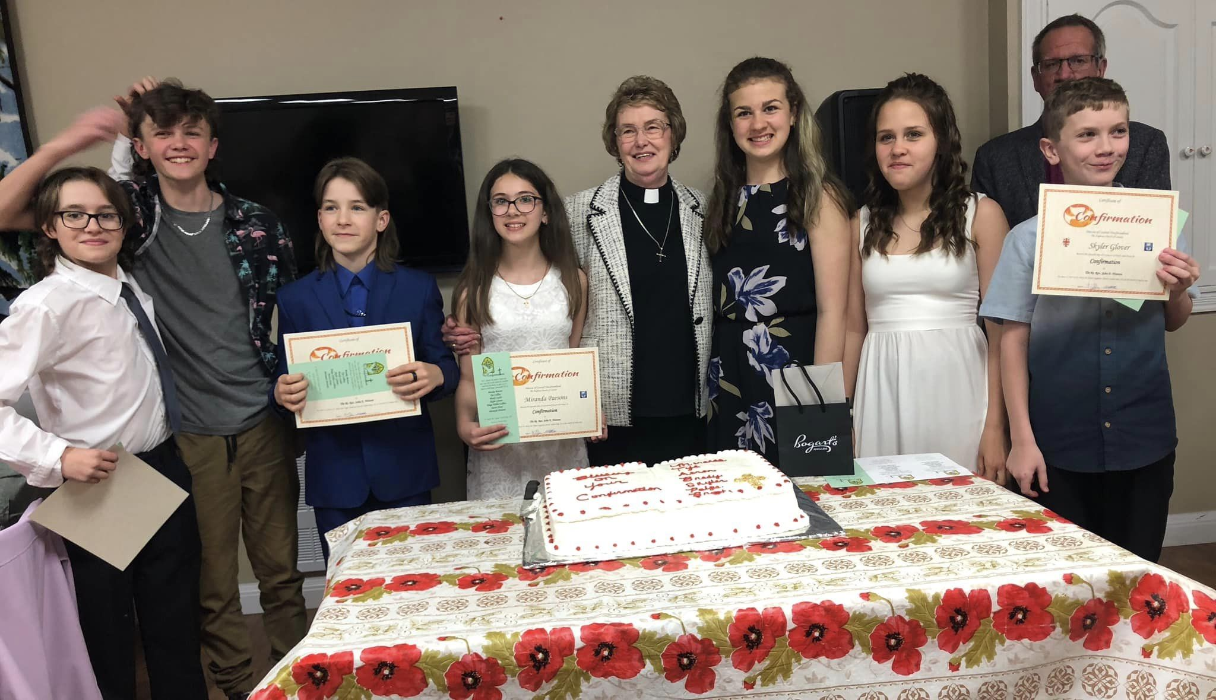

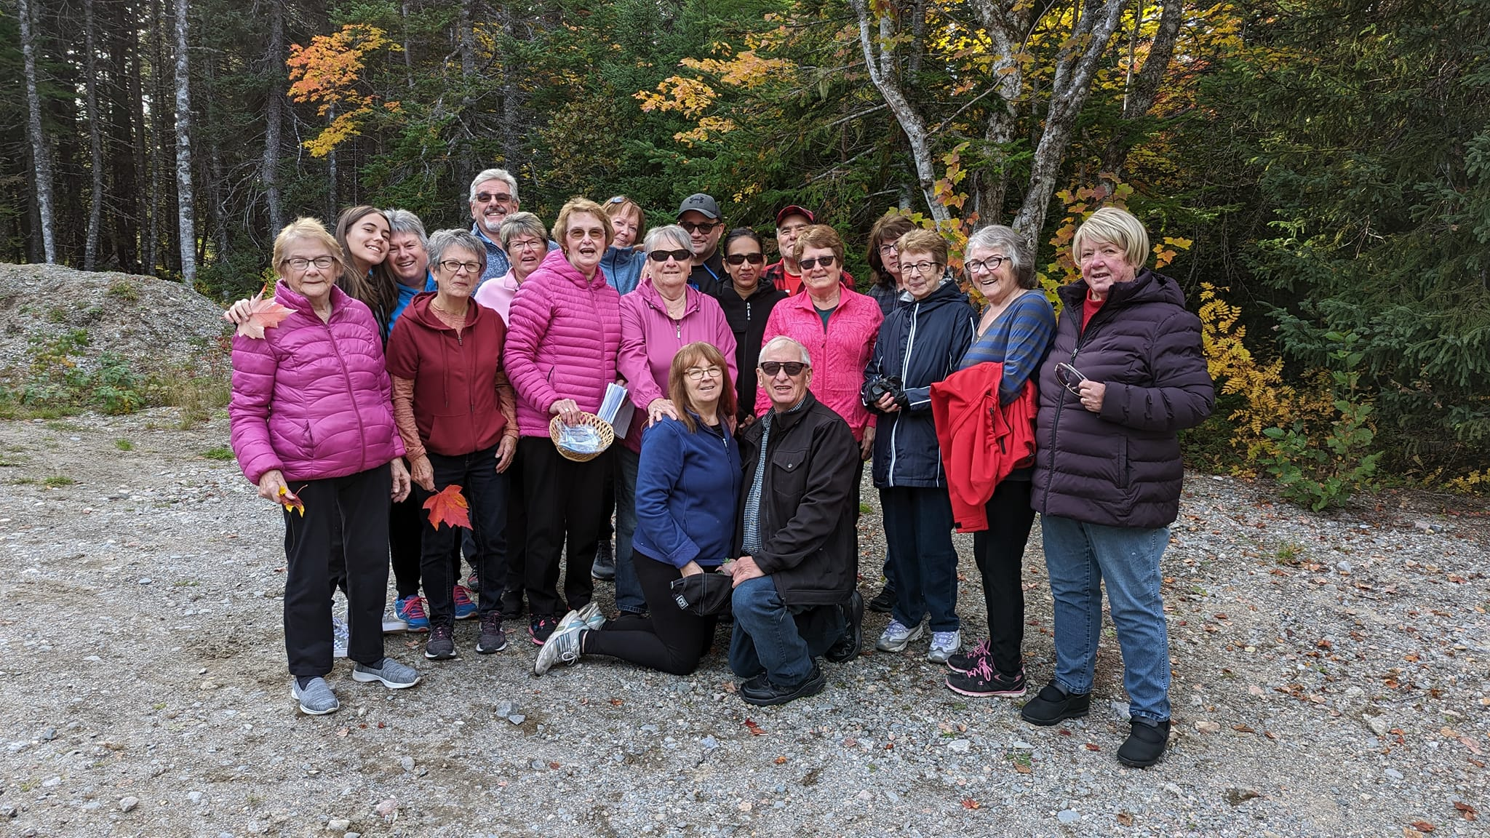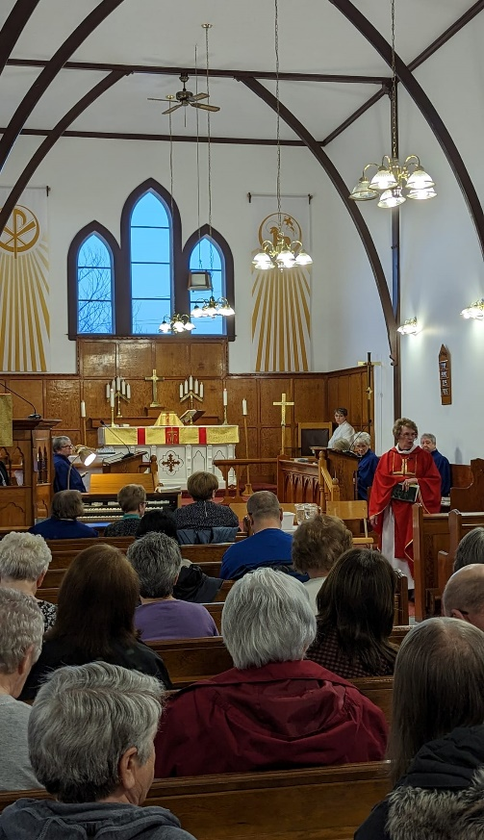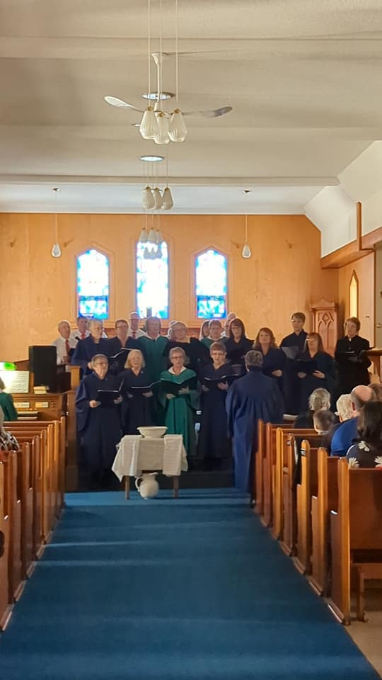

**About Our Diocese**

<http://www.centraldiocese.ca>

The diocese of Central Newfoundland has a relatively new website which is still under development, but a wealth of information is there.

Our present Bishop, The Rt. Revd. John Watton, was consecrated on June 29, 2016.

**The Bishop’s Charge**  
Our Bishop’s first Charge given at The Forty Fourth Session of Synod was extensive as it dealt with current trends and concerns as well as providing a foundation for the visioning and equipping of the diocese in these challenging times.

As a diocese we commit to Collaborative Ministry that is highlighted by clear communication, definitions of accountability, supporting our Clergy and Laity, and highlighting the ideal that we are one family in Christ, by listening with respect, trust and concern for each other.

Our diocese is well known for generous collegiality and the way we support one another!

**Policy On Sustainable & Strategically Missional Ministry**

This policy was published following the diocesan synod of 2017. It is NOT a strategic plan but is a policy that creates an expectation of an ongoing process and provides a method for realistic evaluation within each of our parishes. Every parish in our diocese has been tasked to look at themselves with the view of developing fresh understandings of congregation and parish viability, challenges and possibilities.

**Revisions of Handbook and Constitution**

We are presently reviewing both the constitution and the Bishop’s handbook, with the view of producing living documents that are in touch with the realities of being a Church in our time.

**Ministry Evaluations**

A pastoral tool that supports and enables the ministry of our Clergy keeps us accountable, supported, and in contact with the bishop, and in tune with the spirit’s voice in our midst.

***Feel free to contact our Synod office staff at any time!***